Issue Tracking System

Overview
Planning
- Framework
- UI Design and coding
- Web server
- Database platform
- Automation Testing platform
- Repository
- Security functions
- Initial Functions
- Further Updates

Requirement Analysis
- Application input/output requirements
- Page transition
- Security requirement
- Dependencies requirements

Design
- Application Design
- Rules/Security
- Design Language/Layout
- Programming Language
- Server Design
- Database Relationship

Implementation/Coding
- Hardware
- User interface
- Coding
- Test Case

Testing
- Identify vulnerabilities/bugs
- Check security features
- Requirements met
- Functionality works
- User Experience
- Design Language consistency
- Database

Deployment
- Setting up database on server separated from test server
- Application distribution

Planning

Initial Function [+Permissions]
User account/Settings page (Internal)
Register user account [Administrator] (E)
User login [Everyone] (E)
User update: Change Password [User of account] (S)
User update: Change email, first and last name [Administrator] (S)
User Delete/(Archive) [Administrator] (S)

Issue tracking (Main view) (Internal)
Display Open/In-Prog/Close [All user]
View Change Log [All user]
Update issue status open and in-prog [Contributors]
Update issue status to close [Issue lead]
Archive/Approve closed Issue [Administrator]
Create new issues [User]
Take charge as issue lead [Only when null, User]
Change issue lead [Issue Lead, administrator]
Add contributor [Issue Lead]
Update issue [Issue Lead + contributors]
Create new default tags [Administrator]
Create new default progress stage [Administrator]

Issue tracking (Detailed view) (Internal)
Display issue details
Update issue details, status, etc.
Delete/Archive Issue[Administrator]

Explore (Internal)
Sidebar for navigating

Ticket issue (Internal+External)
User login for ticket (All user)
Automatically create new ticket based on issue tracker (Internal user)
Edit ticket details (Issue lead, administrator)
Message chat for ticket updates and client support (Issue Lead, contributor, a client, administrator)
Close ticket (Issue Lead, administrator)

Extra Features
Notification
Issue tracking (Main view) :
Filter/Search issues
Archive Issue: Auto archiving old closed issue
Download malware sample

Dashboard:
Summary: Current Details/Visualization

Additional shortcut features
Parent/child issue
Toggle theme dynamically

Design
Serverless Design / Design Language

Page Theme
Minimalist
Dark Theme
Curved Edges
Use grids system
Use shadows

Style
Background color: #292929
Container Color: #373737
Container Outline shadow Color: 5pixels outline
Container Outline Color: #707070 (Unused)
Main element(Interactive) color Off: #ABABAB
Main element(Interactive) color On: #2A2A2A
Main element(Interactive) color Pressed: #101010
Main elements Outline Color: #5C5C5C
Text title color: #D8D8D8
Text subtitle color: #7B7B7B
Replaced by PrimeFace styles
Elements
Tier 0(Red Alert): #FF0000
Tier 1(Red): #D9534F
Tier 2(Orange): #F0AD4D

Tier 3(Lime): #5CB85C

To be discussed

Internationalization

File Hierarchy

Testing environment
  - Container with required web environment and DB files for docker to pull

Logging: Log4j (use latest version)

References
- [Icons 4 Design] Free icons no attribute required: http://emsoftware.com/xdplugins/icons-4-design/

UI :https://primefaces.github.io/primefaces/10_0_0/#/?id=main
- Java EE : https://blogs.oracle.com/javamagazine/jakarta-application-server-helidon-piranha-hammock#anchor_1
- Tutorial template: https://github.com/javaee/tutorial-examples
- Session beans: https://docs.oracle.com/javaee/6/tutorial/doc/gipjg.html

Appendix

Vulnerabilities (https://portswigger.net/web-security/all-materials)
Attack | Counter
Injection | Input validation  Parameterized Queries(Prepared statement)  Sanitization
Broken Authentication | Prevent Username Enumeration  2FA  Brute Force Protection  Secure credentials
Sensitive Data Exposure | Encrypt data during transport and at rest.  Minimize data surface area.  Use the latest encryption algorithms.  Disable autocomplete on forms that collect data.  Disable caching on forms that collect data
XML External Entities | Disable XML features that the application does not need or intend to use as application's XML parsing library supports potentially dangerous features
Broken Access Control | Deny access by default  Declare access allowed for each resource
Security Misconfiguration | Disable administration interfaces.  Disable debugging.  Disable use of default accounts/passwords.  Configure server to prevent unauthorized access, directory listing, etc.  Remove unused features.  Consider running scans and doing audits periodically to help detect future misconfigurations or missing patches. (Automation)
Cross-Site Scripting XSS | Encode data on output  Validation  Whitelist instead of blacklist  Avoid user posting HTML markup  htmlentities(PHP)  location.hash(jQuery)  Content Security Policy: Last line of defense
Insecure Deserialization | Do Not Accept Serialized Objects from Untrusted Sources  The Serialization Process Needs to Be Encrypted So That Hostile Object Creation and Data Tampering Cannot Run  Run the Deserialization Code with Limited Access Permissions  Strengthen Your Code’s java.io.ObjectInputStream  Monitoring the Serialization Process Can Help Catch Any Malicious Code and Breach Attempts  Validate User Input  Use a Web Application Firewall That Can Detect Malicious or Unauthorized Insecure Deserialization  Prevent Deserialization of Domain Objects  Use Non-Standard Data Formats  Only Deserialize Signed Data
Vulnerable services/Components | Avoid vulnerable services/components
Insufficient Logging/Monitoring | Log important events
Directory Traversal | Avoid passing user-supplied input to a filesystem API.  Validate user input before processing: compare against whitelist.  Validate input and append the input to the base directory.
Web Cache Poisoning  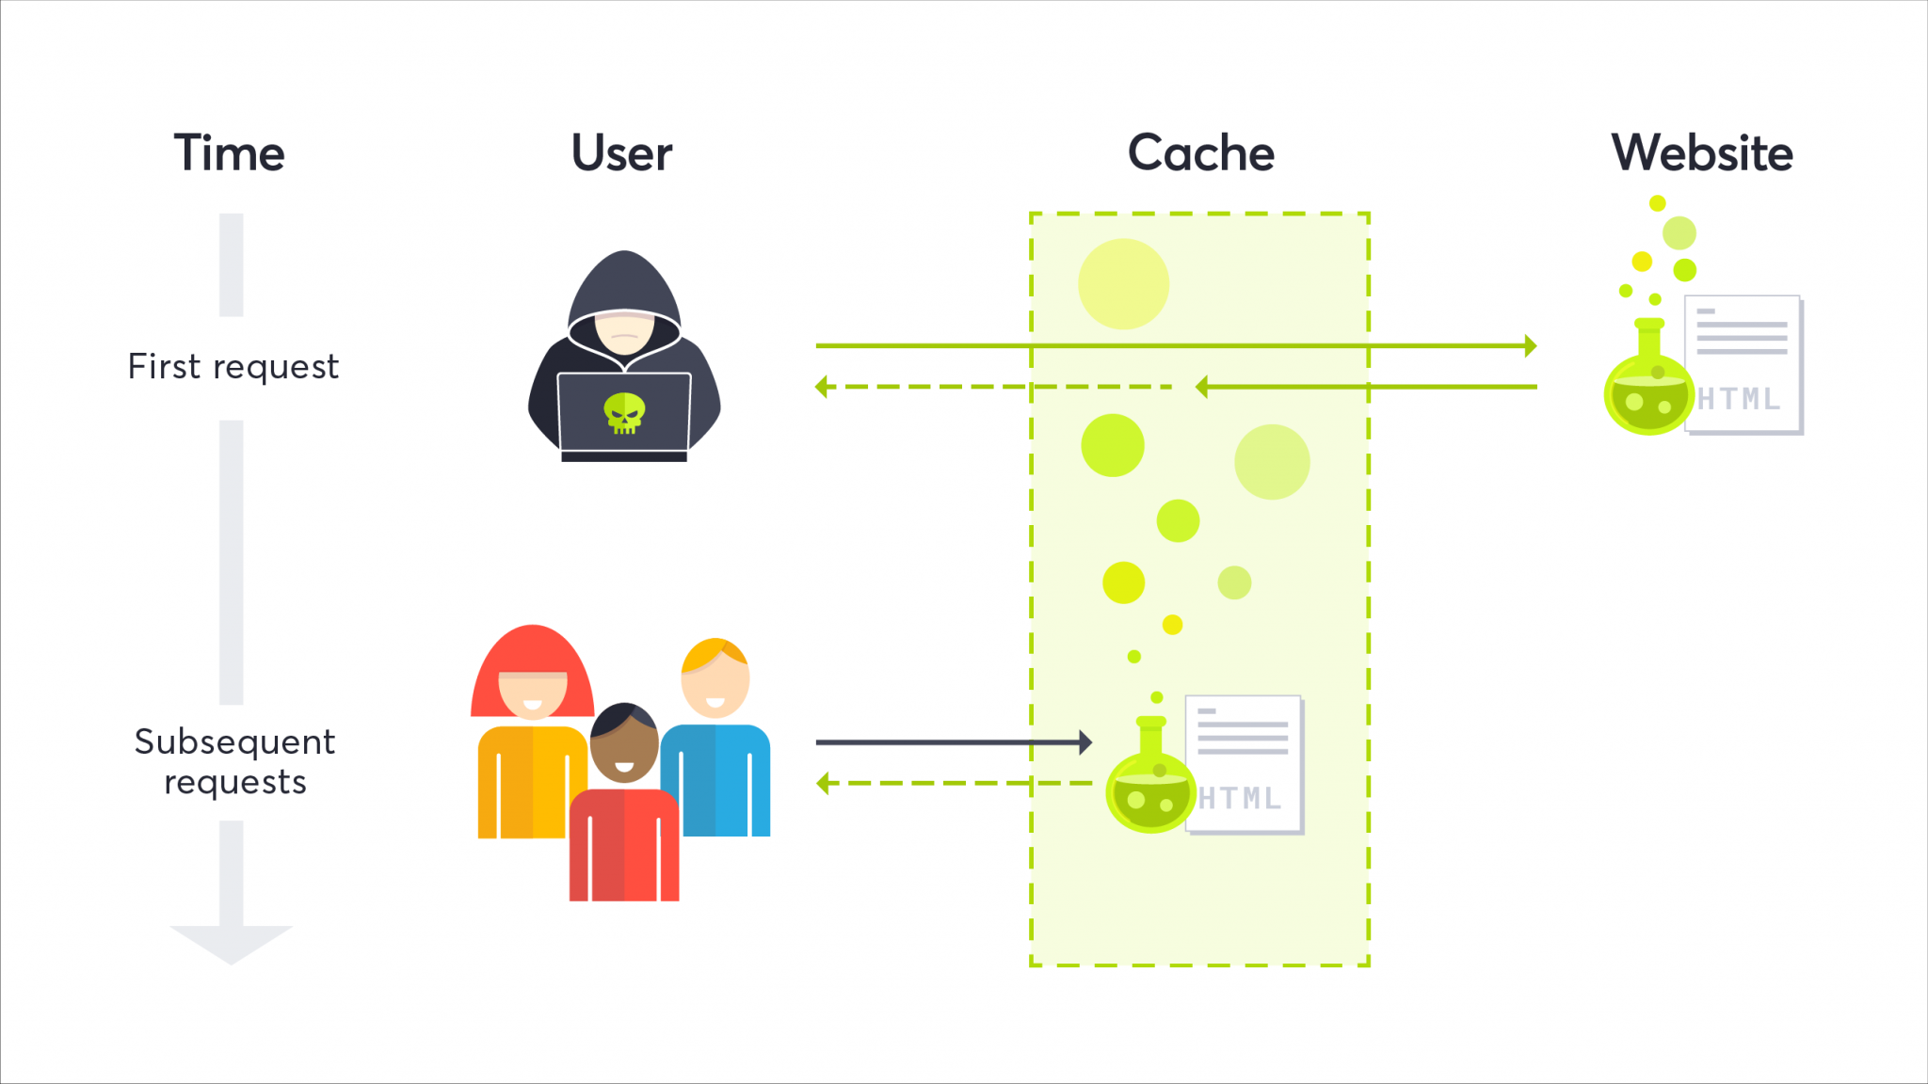  Caching means that you store frequently accessed content in order to speed up subsequent requests to access that content. | Disable caching if possible  Be selective about your unkeyed inputs.  Restrict it to purely static responses if possible  Reject fat GET request
Clickjacking(UI redressing) | Disable framing  CSP
Cross-origin Resource Sharing (CORS): csrf  Caused by misconfiguration | Proper configuration for cross-domain request  Only allow trusted site
Server-side request forgery (SSRF)  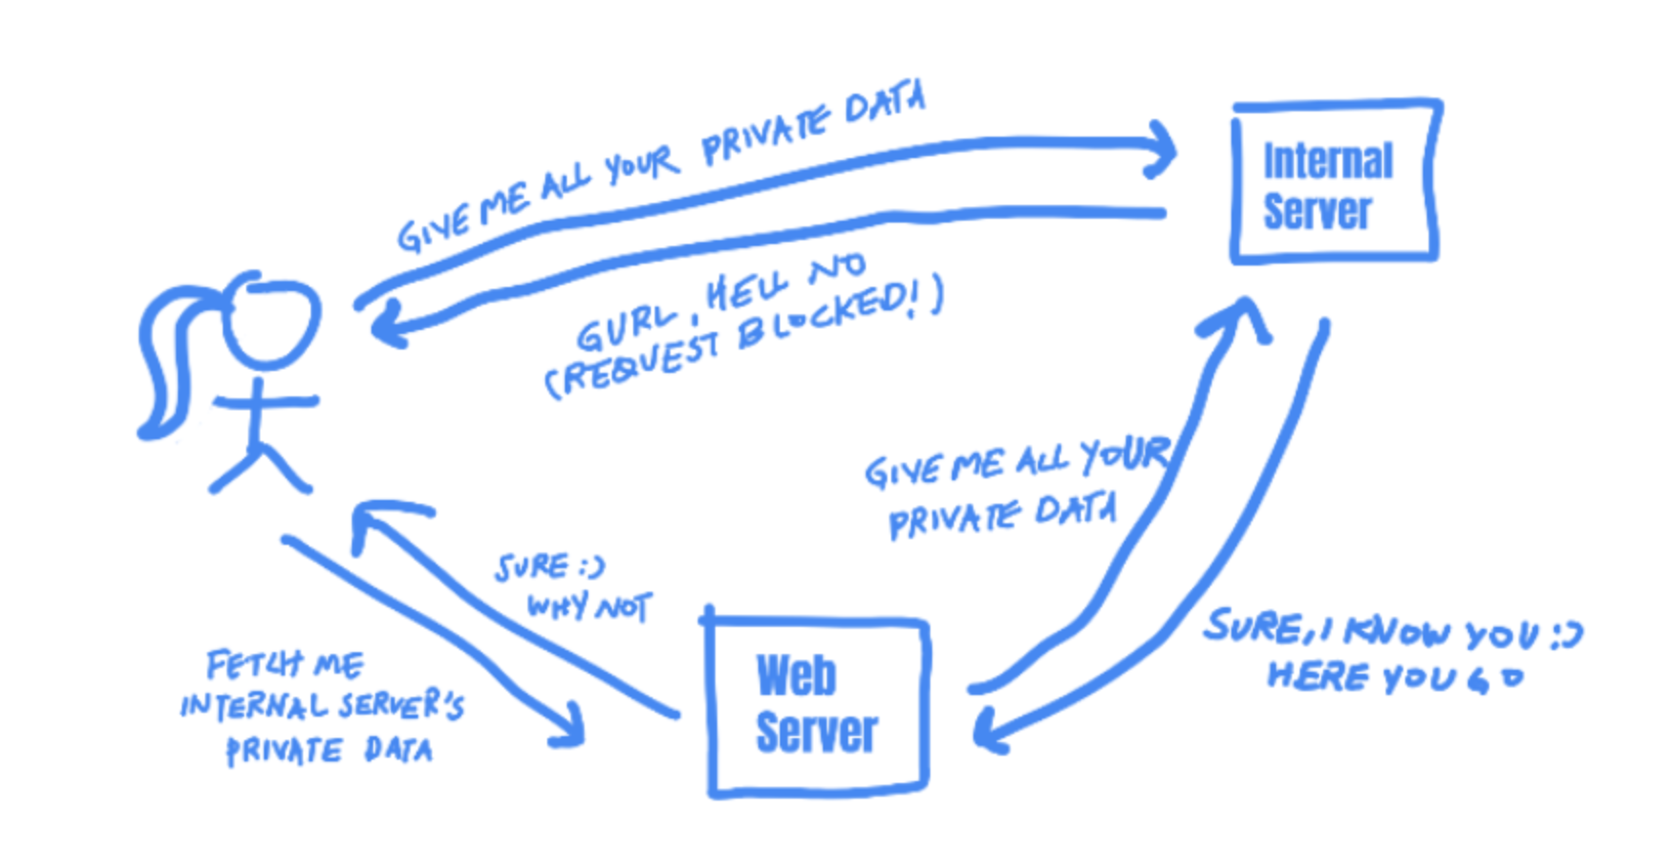  It utilizes an insecure server within the domain as a proxy to attack the target server  https://cheatsheetseries.owasp.org/cheatsheets/Server_Side_Request_Forgery_Prevention_Cheat_Sheet.html | Sanitize input, regex  If your application needs to pass URLs in requests, use a whitelist for IP addresses and domains,  validate responses that have expected format and content.  Ensuring that the data provided is a valid IP V4/V6 address.  Ensure that the IP address provided is whitelisted or trusted.  Using libraries that ensures security of the IP address;  JAVA: Apache Commons Validator  JS: ip-address, is-valid-domain  PYTHON: ipaddress, validators.domain
HTTP request smuggling | back-end request to be sent over a separate network connection.  Use HTTP/2 for back-end connection  same web server software for front and backend server
OS command injection | Avoid calling out to OS command on application level code  whitelist  Validate
Server-side template injection  Template requests data from a user input instead of the database. | Sanitize and validate the user input.
WebSocket security vulnerabilities | use wss:// protocol over TLS  Hardcode URL of the WebSockets endpoint, no user-controllable data  Protect WebSocket handshake message against CSRF.  Treat data received via the WebSocket as untrusted on both client and server end.
DOM-based vulnerabilities | Sanitize all untrusted data  Avoid getting data from the url

Functions requirement
Register user account (Administrator) | Requirement:  Admin only  Logged in  Input:  Username  Email  User Privilege  Process:  Security Function.  Auto generated one-time password sent to email.  Hash+salt password before saving to DB.  Add Username, Email, User Privilege, Password to DB.  Output:  OUTCOME  Future Input:  Profile picture
User login | Requirement:  Logged out  Input:  Email  Password  2FA  Process:  Security Function  hash+salt password  Check input to DB  Output:  OUTCOME  REDIRECT
User update: Change Password | Requirement:  User logged in  User Authorised  Input:  Old Password  New Password  Confirm New Password  Process:  Security Functions  Check if new password matches  Hash+salt old password  Check if Old Password matches the database  If valid Input new hashed password into DB  Output:  OUTCOME + ERROR
User update: Change email, username (Administrator) | Requirements:  Administrator  User logged in  Authorised  Input:  New Email  OR  New Username  Process:  Security Function  Update Email/Username in the DB  Output:  OUTCOME
User Delete/Archive (Administrator) | Requirement:  Administrator  User logged in  Authorised  Input:  Button to archive user  THEN  Reconfirmation to archive user  Process:  Security Functions  Change User status to Archived  Output:  OUTCOME
Display Open/In-Prog/Close: Limited number of closed issue | Requirement:  User logged in  Authorised  Input:  NIL  Process:  Get data from DB  Security Functions  Output:  Issue Number  Title  Type  Priority Level  Status  Progress  Open DateTime  Close DateTime  Due Date  Open User
Change Log | Requirement:  Logged in  Authorised  On specific issue page  Input:  NIL  Process:  Get Data from DB  Security Functions  Output:  Username  Log Changes  Timestamp
Update issue tracking status | Requirement:  Specific Issue  Logged in  Authorised  Input:  New Status Value  Process:  Security Functions  Identify Issue ID  Identify user involved  Update new status value in DB  Output:  Refresh and Updated display
Delete/Archive Issue(Administrator) | Requirement:  Administrator  User logged in  Authorised  Input:  Button to archive Issue  THEN  Reconfirmation to archive Issue  Process:  Security Functions  Change User status to Archived  Output:  OUTCOME
Create new issues | Requirement:  Authorised  Logged in  Input:  Title  Type(optional)  Priority Level  Description(to be expanded on)  - Device Detail(OS, Version)  - Client Personal Details?  - Description of issue  - Anti virus used?  - Malware origin or entry point?  Close By(Optional)  Process:  Security Function  Generate/Obtain Initiator, Progress[0], Issue ID, Open DateTime, Status  Addt to DB  Output:  Outcome/Error
Display issue details | Requirement:  Authorised  logged in  Specific Issue  Input:  NIL  Process:  Obtain DB  Security Functions  Output:  Title  Type(optional)  Priority Level  Description(to be expanded on)  - Device Detail(OS, Version)  - Client Personal Details?  - Description of issue  - ??  Initiator  Progress  Issue ID  Open DateTime  Close DateTime(If closed)  Close By  Status
Update issue details, status, etc. | Requirement:  Logged in  Authenticated(Collab)  Issue Page  Input:  Title  Type(optional)  Priority Level  Description(to be expanded on)  - Device Detail(OS, Version)  - Client Personal Details?  - Description of issue  - ??  Progress  Status  Process:  Security Functions  Update DB  Output:  Outcome/Error
Explore tab for navigating | Requirement:  Logged in  Authorised  Input:  Button  Process:  Security Function  Check button  Output:  Change Page

Security requirements
Attack | Prevention
Injection/Cross-site Scripting  XSS  https://resources.infosecinstitute.com/topic/how-to-prevent-cross-site-scripting-attacks/ | Function  Allow list Input Validation(regex)  Sanitize Output  - Output Encoding  Prepared Statement(Parameterized Queries)  htmlentities(PHP)  location.hash(jQuery)  Use appropriate response headers to ensure that browsers interpret the responses in the way you intend.  Modules  OWASP ModSecurity CRS  - SQL Injection  - PHP Code Injection  - Java Code Injection  - Unix/Windows Shell Injection  Practices  Least DB Privilege to application account.  Multiple DB user for different functions  Whitelist instead of blacklist  Avoid user posting HTML markup  Content Security Policy: Last line of defense
Broken Authentication | Function  Check Username Exist  Random first password (No default pw)  Password Requirements(Client and server side)  - 8 Char, upper/lower case, number, symbol.  2FA  Hash+Salt  Account Lockout (Brute Force)  Time Interval  Captcha  Modules  OWASP ModSecurity CRS  - Scripting/Bot Detection  Practices  Avoid GET use POST  Ensure no sensitive data exposure
Sensitive Data Exposure | Function  Encryption  Avoid exposing error msg to unauthorised user  Disable caching on forms that collect data  Modules  OWASP ModSecurity CRS  - Metadata/Error Leakage  Practice  Ensure no debugging
XML External Entities | Function  XML input validation  Disable Document Type Declaration (DTDs/external entity)  - e.g. factory.setFeature("http://apache.org/xml/features/disallow-doctype-decl", true);  If above is not possible, then  - factory.setFeature(""http://xml.org/sax/features/external-general-entities", false);  Reference: https://xerces.apache.org/xerces2-j/features.html#external-general-entities  Modules  Practices  Disable XML features that the application does not need or intend to use as application's XML parsing library supports potentially dangerous features
Broken Access Control  Session  https://cheatsheetseries.owasp.org/cheatsheets/Session_Management_Cheat_Sheet.html | Function  Session ID (min 50 char)  Employ least privileged concepts  Force all request to go through access control check  Non hardcoded role  Get rid of accounts you don’t need or whose user no longer requires them.  Audit/Log your servers and websites – who is doing what, when, and why.  If possible, apply multi-factor authentication to all your access points.  Disable access points until they are needed in order to reduce your access windows.  Modules  Practices  Deny access by default.  Declare access allowed for each resource.  Remove unnecessary services off your server.  Check applications that are externally accessible versus applications that are tied to your network.
Security Misconfiguration | Function  Configure server to prevent unauthorized access, directory listing, etc.  Running scans and doing audits periodically to help detect future misconfigurations or missing patches. (Automation)  Implement security directives (e.g. hsts, hpkp, x-frame options)  Modules  Practices  Disable administration interfaces.  Disable debugging.  Disable use of default accounts/passwords.  Remove unused features.  Manage error pages - do not share much information such as what web server using or its version
Database misconfiguration  https://cheatsheetseries.owasp.org/cheatsheets/Database_Security_Cheat_Sheet.html#database-configuration-and-hardening  Refer to this for hardening of database  https://dev.mysql.com/doc/refman/8.0/en/security-guidelines.html | Practices  mysql_secure_instilation script to remove default DB and account  Disable file privilege for all users  Disable TCP access, require all access over local socket file or named pipe.  Configure database to only bind on localhost  Restrict access to network ports to specific host with firewalls.  Isolate DB and Application server  Config DB to only allow encrypted connection  Install trusted digital cert on server  Config client app to connect using TLSv1.2+ with modern ciphers  Config client app to very digital cert  Do not use built-in root, sa or SYS account.  No admin rights on DB  Specify allowed host  Limit permission on database(Select, Update, etc)
Insecure Deserialization | Function  Validate User Input  Run the Deserialization Code with Limited Access Permissions  Only Deserialize Signed Data  Modules  Practices  Use Non-Standard Data Formats
Vulnerable services/Components | Function  Modules  Dependency Checker tools  - Retire.JS  - OWASP Dependency Check  Practices  Encapsulate the lib  Avoid vulnerable services/components  Actively maintain and trusted 3rd party library or framework  Keep track of all components/services even during the maintenance stage.
Insufficient Logging/Monitoring  http://www.codediesel.com/software/logging-in-web-development/ | Function  Input validation  Strong access control to logs  Log any user request with sufficient verbose  Modules  Open Source loggers  https://geekflare.com/open-source-centralized-logging/  Log analysis tools  https://opensource.com/article/19/4/log-analysis-tools  https://www.tecmint.com/open-source-centralized-linux-log-management-tools/  Practices  Log important events
Directory Traversal  https://owasp.org/www-community/attacks/Path_Traversal | Function  Validate user input before processing: compare against whitelist, check for encoding.  Validate input and append the input to the base directory.  Giving appropriate permissions to directories and files  Process URI requests that do not result in a file request  When a URI request for a file/directory is to be made, build a full path to the file/directory if it exists, and normalize all characters (e.g., %20 converted to spaces)  Modules  Practices  Avoid passing user-supplied input to a filesystem API.
Web Cache Poisoning | Function  Reject fat GET request  Modules  Practices  Disable caching if possible  Be selective about your unkeyed inputs.  Restrict it to purely static responses if possible  Avoid using user inputs (i.e. HTTP Headers) to be used as the cache key
Clickjacking(UI redressing) | Function  Implement X-Frame-Options HTTP header to indicate whether or not a browser should be allowed to render a page in a <frame>, <iframe> or <object> tag  Implement Content Security Policy  - Content-Security-Policy: frame-ancestors 'none'  - The page cannot be displayed in a frame, regardless of the site attempting to do so.  - Content-Security-Policy: frame-ancestors 'self'  - The page can only be displayed in a frame on the same origin as the page itself.  - Content-Security-Policy: frame-ancestors *uri*  - The page can only be displayed in a frame on the specified origins.  If frame is not needed, use frame-killing on top of the 1st option. Find scripts online.  Modules  Practices  Disable framing  CSP
Cross-origin Resource Sharing (CORS): csrf  Caused by misconfiguration | Function  Validating each and every domain that is requesting your site’s resource  Require credentials from requestors by setting up the header Access-Control-Allow-Credentials  Modules  Practices  Proper configuration for cross-domain request  Only allow trusted site
Server-side request forgery (SSRF)  It utilizes an insecure server within the domain as a proxy to attack the target server  https://cheatsheetseries.owasp.org/cheatsheets/Server_Side_Request_Forgery_Prevention_Cheat_Sheet.html | Function  Validate request sent to the internal application such as strings, IP addresses, domain name, url (Usage of whitelist and blacklist)  Modules  Practices  Sanitize input, regex  If your application needs to pass URLs in requests, use a whitelist for IP addresses and domains,  validate responses that have expected format and content.  Ensuring that the data provided is a valid IP V4/V6 address.  Ensure that the IP address provided is whitelisted or trusted.  Using libraries that ensures security of the IP address;  JAVA: Apache Commons Validator  JS: ip-address, is-valid-domain  PYTHON: ipaddress, validators.domain
HTTP request smuggling | Function  Modules  Practices  back-end request to be sent over a separate network connection.  Use HTTP/2 for back-end connection  same web server software for front and backend server
OS command injection | Function  Validate input  Modules  Practices  Avoid calling out to OS command on application level code  Whitelist  Validate
Server-side template injection  Template requests data from a user input instead of the database. | Function  Sanitize and validate the user input  Modules  Practices
WebSocket security vulnerabilities | Function  Use wss:// protocol over TLS  Hardcode URL of the WebSockets endpoint, no user-controllable data  Treat data received via the WebSocket as untrusted on both client and server end.  Modules  Practices  Protect WebSocket handshake message against CSRF.
DOM-based vulnerabilities  https://portswigger.net/web-security/dom-based | Function  Sanitize all untrusted data  Modules  Practices  Avoid getting data from the url  Avoid allowing data from any untrusted source to be dynamically written to the HTML document

